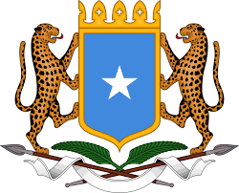

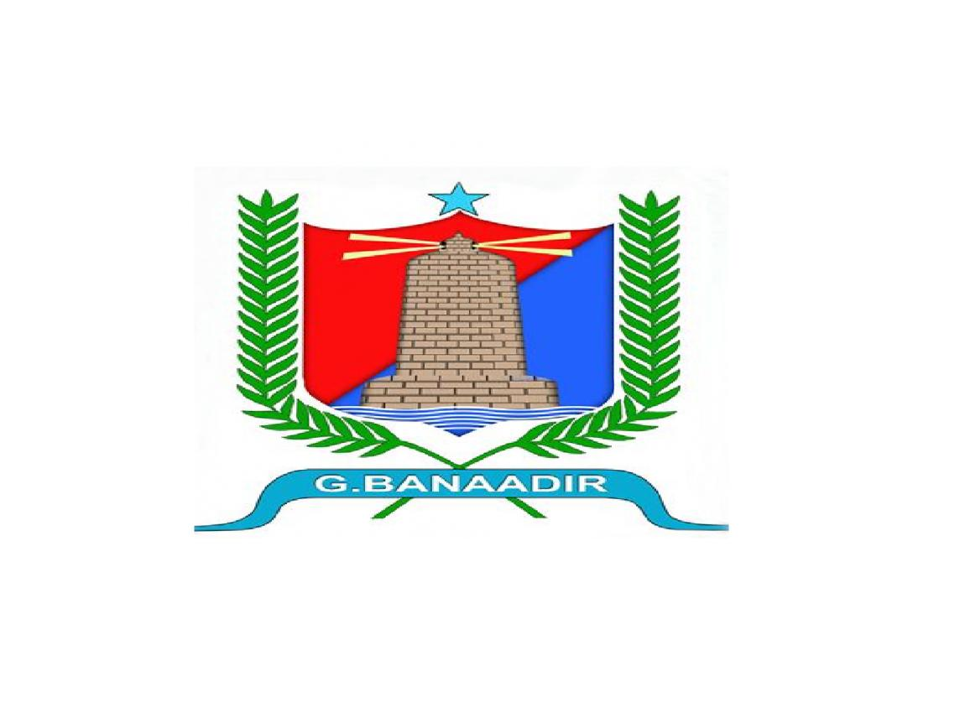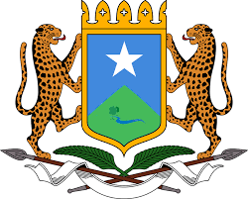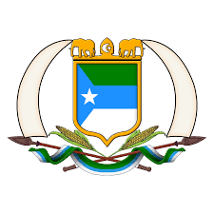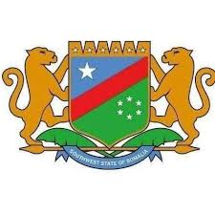

Brief Note on the IGFFTC Nairobi Meeting
Date: | 3rd Oct – 7th Oct 2021
Venue: | Crowne Plaza Hotel, Nairobi
Chairperson: | DG- Revenue & IGFFTC Coordinator
Attendees: | IGFFTC members, DG Ministry of Finance (FGS), officials from the FGS, Kristina- WB Country Manager and other representatives from the WB (see attached Appendix )
Absent: | Abukar Muhuddin (GSS), Ali Jama (PSS), Yusuf Abdullah (JSS)
Purpose of the meeting | Conclusion and finalization of the proposed horizontal allocation formula and discuss on the activities of the annual work plan for the next year
Duration | 3rd – 7th Oct 2021 (8 hours per day)
Scribe: | IGFF Secretariat

Introduction and Opening Statements
The IGFF-TC Secretariat Unit, with the support of the RCRF Project coordination unit, held a physical meeting in Crowne Plaza Hotel, Nairobi, from October 3rd to 6th 2021, to discuss the revenue sharing formula and develop the work plan for the following year.
The meeting was opened with a recitation of verses from the Holy Quran followed by the IGFF-TC chairman’s welcome speech in which he provided a brief update on the achievements made by the committee since its establishment in 2015, including harmonization of sin tax rates, agreement on tax laws and revenue act and most importantly, the sustained cooperation among governments. Similarly, the RCRF Project coordinator commended the achievements made in promoting intergovernmental relations in fiscal federalism through activities streamlined in the project which he emphasized that the success made is being emulated in other sectors like the public sector under the leadership of civil service commissions, education and health. He concluded that Intergovernmental Coordination platforms are taking shape in these sectors these days by achieving common understanding in key intergovernmental cooperation areas. The coordinator concluded that the World Bank team should support project’s priority areas in the coming years including advancing the analytical work of the sector. He mentioned that secretariat work should back up by studies, analytical output that is based on realities on the ground, accommodating views from different sections of the societies – administrations, academicians, and intellectual elites alike. This kind of approach, he said; will project ownership of the process, strengthen legitimacy of the institutions that involve implementation of this activity.
During the opening session of the IGFF-TC meeting, Ms. Kristina- the World Bank country manager, highlighted the importance of developing a predictable, transparent, and appropriate revenue sharing formula in the state-building process but cautioned against rush decisions by the committee members. She spoke on the bases of her experience in supporting other countries in similar activities in the mining sector of the World Bank.
Furthermore, the Director-General of the Somali Ministry of Finance welcomed all the participants and underlined the importance of the harmonization efforts through the power of national unity and the value of cooperation. He further stated that the technical team could influence the politicians' decisions by promoting the national interest and reaching a consensus agreement. Finally, Minister of Finance of FGS officially opened the meeting joining virtually and encouraged the need to explore ways to incentivize performance-based revenue sharing factors to cater the regional income disparity, improve domestic revenue mobilization, and modernize customs and revenue administration. In his concluding remarks, the minister encouraged the team to keep in mind to sound and act as one nation and come up with good ideas for the benefit of the country.
After the first session ended the TC convened and the Chairman reminded non-member committee participants to excuse themselves from the meeting while also reminding TC members of the need to bring sound technical solutions, avoid any communications ambiguity that may cause cascading effects, and employ proper channels to resolve issues.
The IGFF Secretariat Delivered the progress made in the last couple of years and highlighted the challenges encountered. Similarly, the Fiscal Federalism Expert presented to the meeting with the option of raising the equal share weight to 25% of the devisable total but with conditions or to sharply reduce and share equally among the FMSs. The States of Hirshabelle and Galmudug opposed this proposal, insisting that a special reserve be set aside for the three port- less states.
The meeting was reminded that if a FMS replaces members of the TC, it is the responsibility of the replacing administration to provide an update with the new members so that they can better participate in the discussion
Outcome of the TC discussion on the first parameter of the formula (equal share parameter)
The Committee members had a heated discussion on this specific item, and they finally Agreed to defer the discussion on the horizontal allocation formula to the next TC meeting and tentatively scheduled for early January 2022. This was realized after the Committee members failed to agree on the number of factors that would be used for the sharing of grants and revenue despite the fact that four previously proposed have long been the subject of discussion at TC meetings. Differences of opinion among the Committee members regarding the formula have become an issue with the member states of HSH, GSS and SWSS proposing an additional factor (to the previous four) and consider a quota for non-port states, a proposal opposed by JSS and Puntland.
Budget harmonization update
The Deputy Budget Director-FGS delivered a presentation on the progress over the budget harmonization and charts of accounts. With technical support from the IMF, the Deputy Director confirmed that FGS modified the agreed-on version 16 during the meeting in Garowe and produced version 24.
The IGFFTC Budget harmonization sub-committee expressed concern over the communication gap between them and the Federal Department of Budget that undermined their harmonization exercise and that their recommendations were not taken into consideration, requesting that both versions be shared for review and further comments.
The World Bank team presented ideal thought on revenue sharing arrangements for Somalia with possible simulations. The idea proposes the establishment of an equalization pot into which port states contribute 20% of their international trade receipts. As shown in the presentation was that all FMSs would benefit from it, which encouraged the state of SWSS to propose an expansion of the equalization account by offering the port less states the opportunity to contribute.
Representatives from Puntland showed receptiveness to the proposal but expressed concern about the growing fiscal deficit in most FMSs which they believe could prevent them from participating at this time. The state of Juballand also welcomed the idea while noting that it could attract multiple taxations within the FMSs. The BRA also welcomed the pilot proposal and asked a question about the category under which its administration would be placed, with or without port.

The chairman of the IGFFTC reminded the meeting that the presentation seemed well received and that its essence is to preserve the unity of our country and that we have a culture of resource sharing no matter how small.

Finally, the Chairman of the IGFFTC informed the meeting that his meeting with the DGs of the Ministries of Finance resulted in the creation of the following five sub-committees within the IGFFTC:
- Revenue Sub-Committee
- Accounting & Reporting Sub-Committee
- Budget Harmonization Sub-Committee
- Finance, Admin & Capacity Development Sub-Committee
- Research, Planning, and Monitoring & Evaluation Sub-Committee
Agreed Action Points
After three days of heat discussions, the IGFFTC members agreed unanimously on the following action points:
- All the committee members agreed to defer the discussion on the horizontal allocation formula to the next TC meeting and tentatively scheduled on early January 2022.
- Each sub-committee will prepare its annual work plan activities for the FY2022, and will submit them in 15 days from the closing day of the meeting

Done on 6th October 2021
Annex
S/N | Name | Position | Institution
1 | Jafar Mohamed Ahmed | Director General- Revenue | FGS
2 | Abdulkadir Suleiman | RCRF Coordinator | FGS
3 | Abdikarim Mohamed Hussein | Deputy Budget Director | FGS
4 | Ahmed Abdi Mohamed | PFM Coordinator | FGS
5 | jibril Abdi salah | Head of Intergovernmental | FGS
6 | Mohamed Hassan Gelle | Senior F. Reporting Specialist | FGS
7 | Ali Adan Hassan | RCRF Project Secretary | FGS
8 | Ahmed Haji Abdullahi | Fiscal Federalism Expert | FGS
9 | Abdiwahab Omer Jama | IGFFC Member of Secretary | FGS
10 | Abdisamad Abdullahi Mohamed | IGFFC Member of Secretary | FGS
11 | Ahmed Muktar Ali | IGFFC Member of Secretary | FGS
12 | Maxamed Ibraahim Osso | DRM Supervisor | FGS
13 | Khadija sh. Ahmed Moalim hussein | Director General | HSS
14 | Abubakar Yusuf Mohamed | Revenue Director | HSS
15 | Salad Mohamed Nur | Budget Director | HSS
16 | Hashim Mohamed Ahmed | Treasury Reporting Officer | HSS
17 | Abshir Mohamed Abshir | Director General- Revenue | PSS
18 | Osman Sed Elmi | Budget Advisor | PSS
19 | Bahja Abdirizak Abshir | Budget Officer | PSS
20 | Aden Mohamed Hudle | Revenue Director | JSS
21 | Mohamud Abdi Ahmed | Treasury director | JSS
22 | Faysal Muuday | RCRF | JSS
23 | Liibaan Mohamed Mursal | Delegate | SWSS
24 | Abdiaziz Mohamud Hussein | Budget Director | SWSS
25 | Abdulwahid Hussein Hassan | Customs Director | SWSS
26 | Abdullahi Dahir Hussein | Revenue Director | SWSS
27 | Omar Salad Hassan | Finance Officer | BRA
28 | Hassan Mohamed Hassan | Senior Technical Advisor | BRA
29 | Mahad Mohamoud Yalahow | PFM Reform Coordinator | BRA
30 | Mohamed Yusuf Abdulle | Advisor | BRA
31 | Abdiaziz Mohamud Hussein | Budget Director | GSS
32 | ABDIGANI DEGANE SALAT | Customs Officer | GSS
33 | Mustaf Idow | ECF Assistant | FGS
34 | Saaed Gealle Jama | Inland Revenue Director | GSS
35 | Kristina | World Bank Country Manager | World Bank
36 | Zubair | World Bank Task Team Leader | World Bank
37 | Gael |  | World Bank
38 | Mohamud Yasin |  | World Bank
39 | Alma |  | World Bank

