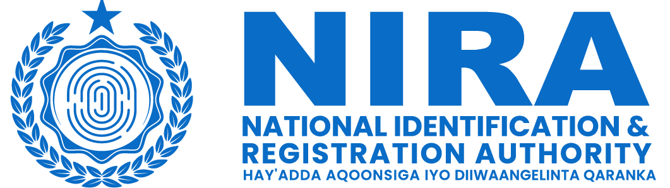

Organization: | National Identification and Registration Authority (NIRA)
Position: | Database Administrator
Location: | Mogadishu
Reporting to:  Contract Duration  No. of Positions | Director of Information Systems Development  1 year with possible extension

TERMS OF REFERENCE FOR DATABASE ADMINISTRATOR
Background:
The National Identification and Registration Authority (NIRA) is a Government Agency in Somalia, first established in 2020, with the aim of creating and maintaining the national identification system. NIRA is, inter alia, responsible for registering citizens and residents and for providing them with secure and verifiable credentials, including a unique identification number and a national identity card. It also serves as a trusted provider of identity verification and authentication services, promoting the use of the foundational identification system. With the establishment of NIRA Somalia, the government is committed to providing a reliable and efficient identification system that will enable individuals to access services and participate in the development of the country.
The Federal Government of Somalia is implementing the World Bank-financed Somalia Capacity Advancement, Livelihood and Entrepreneurship, through Digital Uplift Project (SCALED-UP) and intends to use part of the proceeds to hire a Database Administrator (Individual Consultant) for the National Identification and Registration Authority.

NIRA seeks to recruit a Database Administrator to:
- Install, configure, and upgrade database software and related tools to support the management of national databases.
- Monitor database performance, conduct regular performance tuning, and optimize queries for maximum efficiency.
- Develop and implement data security policies, procedures, and best practices to protect identity information of citizens and residents in the country.
- Conduct database capacity planning to anticipate future storage and performance needs.
- Generate regular reports on database performance, usage, and security compliance for NIRA’s management.

Scope of Work:
Under the overall guidance from NIRA Director General and direct supervision from the director of Information Systems Development, the responsibilities of the Database Administrator will include but not limited to the following:
- Install, monitor, and troubleshoot RDBMS packages and tools in test, development, and production environments.
- Install, monitor, and troubleshoot databases related to SNIDS and other applications.
- Develop and implement database backup and recovery strategies to ensure data reliability and minimize downtime.
- Perform routine maintenance tasks, such as database backups, index rebuilding, and statistics gathering.
- Develop and implement data security policies, procedures, and best practices to protect sensitive identity information in the national database.
- Identify and resolve database performance issues, such as slow queries, inefficient indexing, or resource contention.
- Implement and maintain database monitoring tools to proactively identify and resolve issues.
- Manage Backups, restoration and archiving of databases and database objects.
- collaborate with system and application developers on design, development, documentation, and testing activities.
- Providing proactive and reactive data management support and training to users
- Create and maintain comprehensive documentation of database systems, including schema, configurations, and standard operating procedures.
- Preform Impact analysis on database changes.
- Grant the appropriate access to authorized users.

Qualification and experience requirements:
- A bachelor’s degree in computer science, Information Technology, or a related field.
- Minimum of 3 years of proven work experience as a Data Base Administrator, specifically in the government institutions.
- Extensive experience with database technologies (MySQL, MS SQL, PostgreSQL Oracle, MongoDB)
- Proficiency in writing complex SQL queries and optimizing database performance.
- Advanced certification as an MCDBA or MCSD for .NET, Microsoft, Azure database Administrator Associate, Oracle Database SQL certified Professional, mySQL database administrator is advantageous.
- Strong knowledge of database tasks including database performance tuning, database security, database backups, promoting process improvement.
- Ability to train users on database concepts and methodologies as well as specific
application utilization and configuration.
- Excellent analytical, problem-solving, communication, and interpersonal skills.
- Up to date with trends and developments in database administration.
- Fluent in English and Somali is required.

Deliverables:
- Database security policies, procedures, and best practices to protect identity information of citizens and residents in the country.
- Database backup and recovery strategies to ensure data reliability and minimize downtime.
- Database capacity plan to anticipate future storage and performance needs.
- Detailed and comprehensive documentation of database systems, including schema, configurations, and standard operating procedures.
- Regular reports on database performance, usage, and security compliance for NIRA’s management including visualizations, and dashboards.
- Collaborate with other teams in capacity building and knowledge transfer activities.
- Recommendations to emerging database technologies and their implementation.
- Provide proactive and reactive data management support and training to users.

