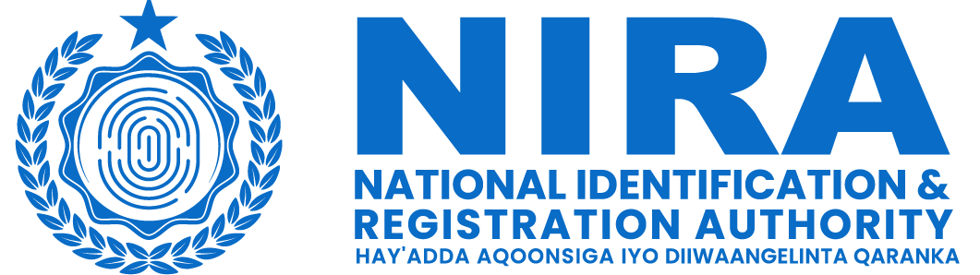

Organization: | National Identification and Registration Authority (NIRA)
Position: | South West State Focal Point
Location: | South West State
Reporting to:  Contract Duration | Director of Operations  12 months renewable upon performance

TERMS OF REFERENCE FOR THE South West State Focal Point
Background:
The National Identification and Registration Authority (NIRA) is a Government Agency in Somalia, first established in 2020, with the aim of creating and maintaining the national identification system. NIRA is, inter alia, responsible for registering citizens and residents and for providing them with secure and verifiable credentials, including a unique identification number and a national identity card. It also serves as a trusted provider of identity verification and authentication services, promoting the use of the foundational identification system. With the establishment of NIRA Somalia, the government is committed to providing a reliable and efficient identification system that will enable individuals to access services and participate in the development of the country.

The Federal Government of Somalia is implementing the World Bank-financed Somalia Capacity Advancement, Livelihood and Entrepreneurship, through Digital Uplift Project (SCALED-UP) and intends to use part of the proceeds to hire Focal Point (Individual Consultant) for South West State for the National Identification and Registration Authority

Scope of Work:
Under the overall guidance from NIRA Operations Director, the responsibilities of the South West State Focal Point will include but not limited to the following:

- Coordinate and lead the implementation of the National ID program in South West State.
- Serve as the main point of contact and liaison between NIRA and the South West State authority, ensuring effective communication and collaboration.
- Lead and supervise the NIRA staff in the South West State, providing guidance and support for the successful implementation of the National ID program.
- Engage with South West State leaders, local government agencies, and relevant stakeholders in South West State to foster partnerships and ensure their support and involvement in the National ID implementation.
- Conduct regular meetings and consultations with South West authority and stakeholders in South West to address concerns, provide updates, and gather feedback on the National ID program.
- Coordinate with civil society organizations and community leaders to promote awareness and understanding of the National ID program among the local population.
- Monitor and evaluate the progress of the National ID implementation in Sou West State, identifying challenges and proposing solutions for improvement.
- Provide regular reports to NIRA on the status of the National ID program South West State, including achievements, challenges, and recommendations.

Qualifications and Experience:
- Bachelor's degree in a relevant field, such as computer science, Information Technology, public administration, or project management. Master's degree is preferred.
- Minimum of 7 years of experience in government, project management, or related fields, preferably with experience in ID systems implementation or in programs of similar complexity and scale.
- Knowledge and understanding of the regional context and governance structures in South West State
- Strong leadership and coordination skills, with the ability to effectively manage a team and engage with diverse stakeholders.
- Experience working with government agencies/civil society organizations, or development partners.
- Excellent communication and interpersonal skills, analytical, problem-solving, with the ability to build and maintain relationships with FMS leaders and other stakeholders.
- Proven ability to work independently, prioritize tasks, and meet deadlines.
- Fluency in English and Somali languages (both written and spoken).
- Proficiency in Microsoft Office Suite and, Excel, Project Management Tools, other relevant software applications. presentations, and other documents as required by the management of NIRA.

Deliverables:
- Comprehensive Implementation Plan: develop a detailed implementation plan for the National ID program in South West, outlining the key activities, timelines, and necessary resources for successful execution.
- Stakeholder Engagement: Engage with FMS leaders, government agencies, civil society organizations, public and private sectors, and other stakeholders in South West State to ensure their active participation and support in the National ID program. Provide monthly reports of engagements, key outcomes, and follow-up actions.
- Coordination and Supervision: Effectively coordinate and supervise the NIRA staff in South West, ensuring their adherence to the implementation plan and achievement of set targets.
- Compliance with Standards and Guidelines: Ensure that NIRA staff in South West adhere the established standards, guidelines, and data protection regulations.
- Monitoring and Evaluation: Monitor and evaluate the progress of the National ID program in South West State, identifying any issues or bottlenecks and proposing corrective measures.
- Implementation Progress Reports: Prepare regular progress reports on the National ID implementation in South West, highlighting achievements, challenges, and recommendations for improvement.
- Lessons Learned and Best Practices: Identify and document lessons learned and best practices from the National ID implementation in South West State, sharing them with NIRA for knowledge sharing and future improvements.
- Final Report: Prepare a comprehensive final report summarizing the outcomes, achievements, challenges, and recommendations of the National ID implementation in South West.

